|  |  |  |  |  |
| --- | --- | --- | --- | --- |
|  |  | | |  |
|  |  | | |  |
|  | Function Group Spec  Driver Information System  NFC Starting & Entry | | |  |
|  |  |
|  |  |
|  |  | | |  |
| Document Type | **Function Specification** | | |  |
| Template Version | **6.0** | | |  |
| SysML Report Template Version | **M (4/16/2019)** | | |  |
| Document ID | **2021-06-07** | | |  |
| Document Location |  | | |  |
| Document Owner | **Aaron Bonnell-Kangas (abonnel1)**  **Aaron DeLong (adelong2)**  **Farhan Ehsan (fehsan1)**  **Eugene Karpinsky (ekarpins)**  **Reinaldo Sepulveda (spepulv6)**  **Jonathon Wolf (jwolf53)** | | |  |
| Document Revision | **FGS0** | | |  |
| Document Status | **Release** | | |  |
| Date Issued | **2020-08-24** | | |  |
| Date Revised | **2021-06-07** | | |  |
| Document Classification | GIS1 Item Number: | **27.60/35** | |  |
| GIS2 Classification: | **Confidential** | |
|  | | | | |
|  | | | | |
| Document Approval | | | | |
| Name | Role | | Email Confirmation | Date |
|  |  | |  |  |
|  |  | |  |  |

Printed Copies are Uncontrolled

# Disclaimer

**This document contains Ford Motor Company Confidential information. Disclosure of the information contained in any portion of this document is not permitted without the expressed, written consent of a duly authorized representative of Ford Motor Company, Dearborn, Michigan, U.S.A.**

**Copyright, Ó 2021 Ford Motor Company**

This document contains information developed and accumulated by and for FORD MOTOR COMPANY. As such, it is a proprietary document, which, if disseminated to unauthorized persons, would provide others with restricted information, data, or procedures not otherwise available, exposing the FORD MOTOR COMPANY to potential harm.

Employees and suppliers having custody of this specification or authorized to use it must be cognizant of its proprietary nature and ensure that the information herein is not made available to unauthorized persons.

FORD MOTOR COMPANY reserves the right to protect this work as an unpublished copyrighted work in the event of an inadvertent or deliberate unauthorized publication. FORD MOTOR COMPANY also reserves its rights under copyright laws to protect this work as a published work.

This document or portions thereof shall not be distributed outside FORD MOTOR COMPANY without prior written consent. Refer all questions concerning disclosure to the author(s) or to any duly authorized representative of Ford Motor Company.

# Contents

Disclaimer 2

Contents 3

1 Introduction 4

1.1 Document Purpose 4

1.2 Document Audience 4

1.2.1 Stakeholder List 4

1.3 Document Conventions 6

1.3.1 Terminology 6

2 Logical Architecture 8

2.1 Structure 8

2.2 Logical Architecture 9

3 Function Group Description 10

3.1 Logical System Behavior 10

3.2 Logical System Requirements 10

4 Revision History 14

5 Appendix 15

5.1 Data Dictionary 15

5.1.1 Logical Messages 15

5.1.2 Logical Data Types (encodings) 15

5.1.3 Technical Signals 15

**List of Figures**

Figure 1: NFC Logical Domain Structure 8

Figure 2: NFC Logical Architecture 9

Figure 3: Driver Information System 10

# Introduction

## Document Purpose

The Function (Group) Specification (FS) specifies an individual function / a group of functions.

To get more information about the concept of feature, function and component level abstraction refer to the [Ford RE Wiki](http://wiki.ford.com/display/RequirementsEngineering/Requirements+Engineering+for+SW+Enabled+Features).

## Document Audience

The FS is authored by the owners of the individual functions. All Stakeholders, i.e., all people who have a valid interest in the functions and their behavior should read and, if possible, review the FS. It needs to be guaranteed, that all stakeholders have access to the currently valid version of the FS.

### Stakeholder List

|  |  |  |  |  |
| --- | --- | --- | --- | --- |
| **Name** | **CDSID** | **Org.** | **Title** | **Project Role** |
| John Van Wiemeersch | jvanviem | RA&E, Adv. Feat. Development | Supervisor | Design Support |
| Aaron DeLong | adelong2 | RA&E, Adv. Feat. Development | Research Engineer | Research Design Lead |
| Vivek Elangovan | velango5 | RA&E, Adv. Feat. Development | Research Engineer | Design Support |
| Rita Trupiano | mtrupia1 | PD, Sys. Eng.,  Distributed Feat. | Feature Owner Supervisor | Feature Owner Supervisor |
| Eugene Karpinsky | ekarpins | PD, Sys. Eng.,  Distributed Feat. | Core Feature Owner | Production Design Lead and Feature Owner |
| Farhan Ehsan | fehsan2 | PD, Sys. Eng.,  Distributed Feat. | Core Feature Owner | Production Design Lead and Feature Owner |
| Aaron Bonnell-Kangas | abonnel1 | PD, Sys. Eng.,  Distributed Feat. | Core Feature Owner | Production Design Lead and Feature Owner |
| Jonathon Wolf | jwolf53 | PD, Sys. Eng.,  Distributed Feat. | Core Feature Owner | Production Design Lead and Feature Owner |
| Matt Swis | mswis | PD, EESE, Body & Security Elec. | Core Security & RF Supervisor | NFC System Owner Supervisor |
| Nisha Patel | npate152 | PD, EESE, Body & Security Elec. | Core NFC Engineer | NFC System Owner |
| David Hernandez | dhern138 | PD, EESE, Body & Security Elec. | Core NFC Engineer | NFC System Owner |
| Suthagaran Nagarasa | snagaras | PD, EESE, Body & Security Elec. | Core NFC Engineer | NFC System Owner |
| Kevin Hille | khille | PD, EESE, Body & DAT SW | Technical Specialist – Immob. | NFC Immobilizer Function Owner, Design Support |
| John Ricks | jricks7 | PD, EESE, Body & DAT SW | Software Supervisor | Software Supervisor |
| John Popovecz | jpopovec | PD, EESE, Body & DAT SW | Body Module SW Supervisor | Body Module SW Supervisor |
| Hosam Irsheid | hirsheid | PD, EESE, Body & DAT SW | Software Engineer | Software Design |
| Sam Mehdi | hmehdi | PD, EESE, Body & DAT SW | Product Design Engineer | Software Design |
| Vishala Pasala | vpasala | PD, EESE, Body & DAT SW | Software Engineer | Software Design |
| Maeen Mawari | mmawari | PD, EESE, Body & DAT SW | MBSE Engineer | Software Design |
| Eric Reed | ereed2 | PD, EESE, Body & DAT SW | VSC SW Engineer | Software Design |
| Ahmad Sabri | asabri3 | PD, EESE, Body & DAT SW | PD Engineer | Software Design |
| Jeff Lossing | jlossing | PD, EESE, Body & DAT SW | Software Engineer | Software Design |
| Andrew Hall | ahall185 | PD, EESE, Body & DAT SW | Design Engineer, BCM Software | Software Design |
| Sachin Magar | smagar | PD, EESE, Body & DAT SW | Design Engineer, BCM Software | Software Design |
| Akshita Kulkarni | akulka2 | PD, EESE, Body & DAT SW | Design Engineer, BCM Software | Software Design |
| Adithya Ramachandran | aramac11 | PD, EESE, Body & DAT SW | Software Engineer | Software Design |
| S Bagga | sbagga11 | PD, EESE, Body & DAT SW | Software Engineer | Software Design |
| Gail Cheng | gcheng | PD, In-Vehicle Infotainment & Connectivity | Infotainment Systems Supervisor | Infotainment System Design Supervisor |
| Matthew Borrelli | mborrel4 | PD, In-Vehicle Infotainment & Connectivity | Infotainment Systems Engineer | Infotainment System Design |
| Laura Check | lburek | PD, In-Vehicle Infotainment & Connectivity | SYNC Supervisor | SYNC System Supervisor |
| Iqbal Faheem Sayyed | isayyed | PD, In-Vehicle Infotainment & Connectivity | SYNC Technical Program Manager | SYNC Technical Program Manager |
| Scott Watkins | swatkins | PD, In-Vehicle Infotainment & Connectivity | DI Technical Expert | Driver Information Design Support |
| Stavros Dionyssopoulos | sdionyss | PD, CIED | DI HMI Engineer | Driver Information HMI Support |
| Nicholas Davio | ndavio | PD, CIED | HMI Supervisor | HMI Support Supervisor |
| Mack Dobbie | mdobbie | PD, CIED | HMI Designer | HMI Support |
| Montana Pruett | mpruett2 | PD, CIED | I&E Engineer | I&E Support |
| Patrick Brautigan | pbrautig | PD, CIED | UX Engineer | UX Support |
| Jeffrey Hamel | jhamel7 | PD, Enterprise Connectivity | Product Owner, TPM | Ford Mobile App Design |
| Michael Martinez | mmart664 | PD, Mobility | Product Manager | Ford Mobile App Design |
| Bruce Williams | bwilli28 | PD, EESE, Netcom Core | Product Design Engineer | Electrical Architecture Consult |
| Jim Lawlis | jlawlis | PD, EESE, Advanced Netcom | Technical Specialist - Netcom | Electrical Architecture Consult |
| Nhi Torres | ntorres5 | PD, EESE, Netcom Diag. | Supervisor | Electrical Architecture Consult |
| Eric Paton | epaton | PD, EESE, Netcom Diag. | Engineer | Electrical Architecture Consult |
| Ankita Vyas | avyas8 | PD, EESE, Functional Safety | Functional Safety Engineer | Functional Safety Consult |
| Ahmet Cinar | acinar1 | PD Europe, Underbody EESE | Tech. Expert – Closure Electronics | Closure Design Consult |
| Uwe Zank | uzank | PD Europe, Underbody EESE | Supervisor, Security Electronics | Security Design Consult |
| Denney Vellaramkalayil | dvellara | PD Europe, Underbody EESE | System Engineer, Locking Application | Locking Design Support |
| Henry Popow | hpopow | Quality, EESE | Quality Engineer | Quality Coach |
| Gerard Szczepaniak | gszczepa | Quality, EESE | Quality Engineer | Quality Coach |
| Christina Bloxsom | cbloxsom | SE&SE, ASO, Adv. Policy | Subject Matter Expert | Safety & Regulations Consult |
| Mike Westra | mwestra | IT, Cybersecurity | Technical Leader – Security | Cybersecurity Consult |
| Jochen Schubert | jschub1 | IT, Cybersecurity | Cybersecurity Engineer | Cybersecurity Design Support |
| Dan Zajac | dzajac8 | IT, Cybersecurity | Cybersecurity Supervisor | Cybersecurity Supervisor |
| Jacob Nelson | jnels148 | IT, Cybersecurity | Cybersecurity Engineer | Cybersecurity Design Support |
| Xin Ye | xye7 | IT, Cybersecurity | Technical Specialist - Security | Cybersecurity Consult |
| Simon Hurr | shurr | IT, Cybersecurity | Security Application Specialist | Cybersecurity Consult |
| Mike Simons | msimon78 | IT, CVP&P, PaaK | Systems Engineer | Off Board Function Owner Lead |
| Faten Fawaz | ffawaz | IT, CVP&P, Basic Design | Basic Design Architect | Backend Infrastructure Design Lead |
| Steve Craig | scraig33 | IT, CVP&P, Integration | Technical Program Manager | Backend Infrastructure Design Support |
| Yona Shaposhnik | yshaposh | IT, MPS, Mobility Arch. | Solution Architect | Backend Infrastructure Design Support |
| Michelle Moody | mmoody1 | IT, Mobility, FCS | Director | Project Champion – Fleet |
| Robert Johnson | rjohns75 | IT, Mobility, FCS | Product Marketing Manager | Project Champion – Fleet |
| Mustapha Elkhatib | melkhat1 | IT, Mobility, FCS | Product Manager | Fleet Infrastructure Design Support |
| Geoffrey Scofield | gscofiel | IT, Mobility, FCS | Product Engineer | Fleet Infrastructure Design Support |
| Jennifer Oak | joak | MS&S, US Marketing | Connected Marketing Manager | Project Champion – Retail |
| Timothy Son Hing | tsonhin1 | MS&S, US Marketing | Marketing Manager | Project Champion – Retail |

## Document Conventions

### Terminology

When referring to aspects of the system design, this document uses standardized language to avoid ambiguity and confusion. The following terms are of particular relevance to this document:

|  |  |
| --- | --- |
| **Term** | **Definition** |
| Configuration parameter | A property of a system that is stored in nonvolatile memory and not expected to be changed during system operation. Examples include assigned serial numbers that are unique to each module and static. |
| Runtime variable | A property of a system that can be read and modified during normal system operation. The variable might be stored in volatile or nonvolatile memory. Examples include stored/saved records, system states, and measured values. |
| Message | A message defines a data structure whose elements are all transmitted simultaneously. The message might be transmitted within a single system, or across a network between two separate systems.  The term “message” is used here to reduce confusion when discussing automotive system behaviors. As it is used in this document, a “message” is identical to the concept of a “signal” as defined in UML/SysML.  A message may or may not contain *signals* – see below. |
| Signal | A signal is a single data element within a message. A signal cannot be transmitted independently of a message, but a message can be transmitted without any signals.  As it is used in this document, a signal corresponds to the UML/SysML concept of a *property*. |

# Logical Architecture

The NFC Entry and Starting feature is designed assuming the following system structure. The components shown are the logical systems; they may map one-to-one onto a physical module, or one physical module might house multiple logical systems.

## Structure

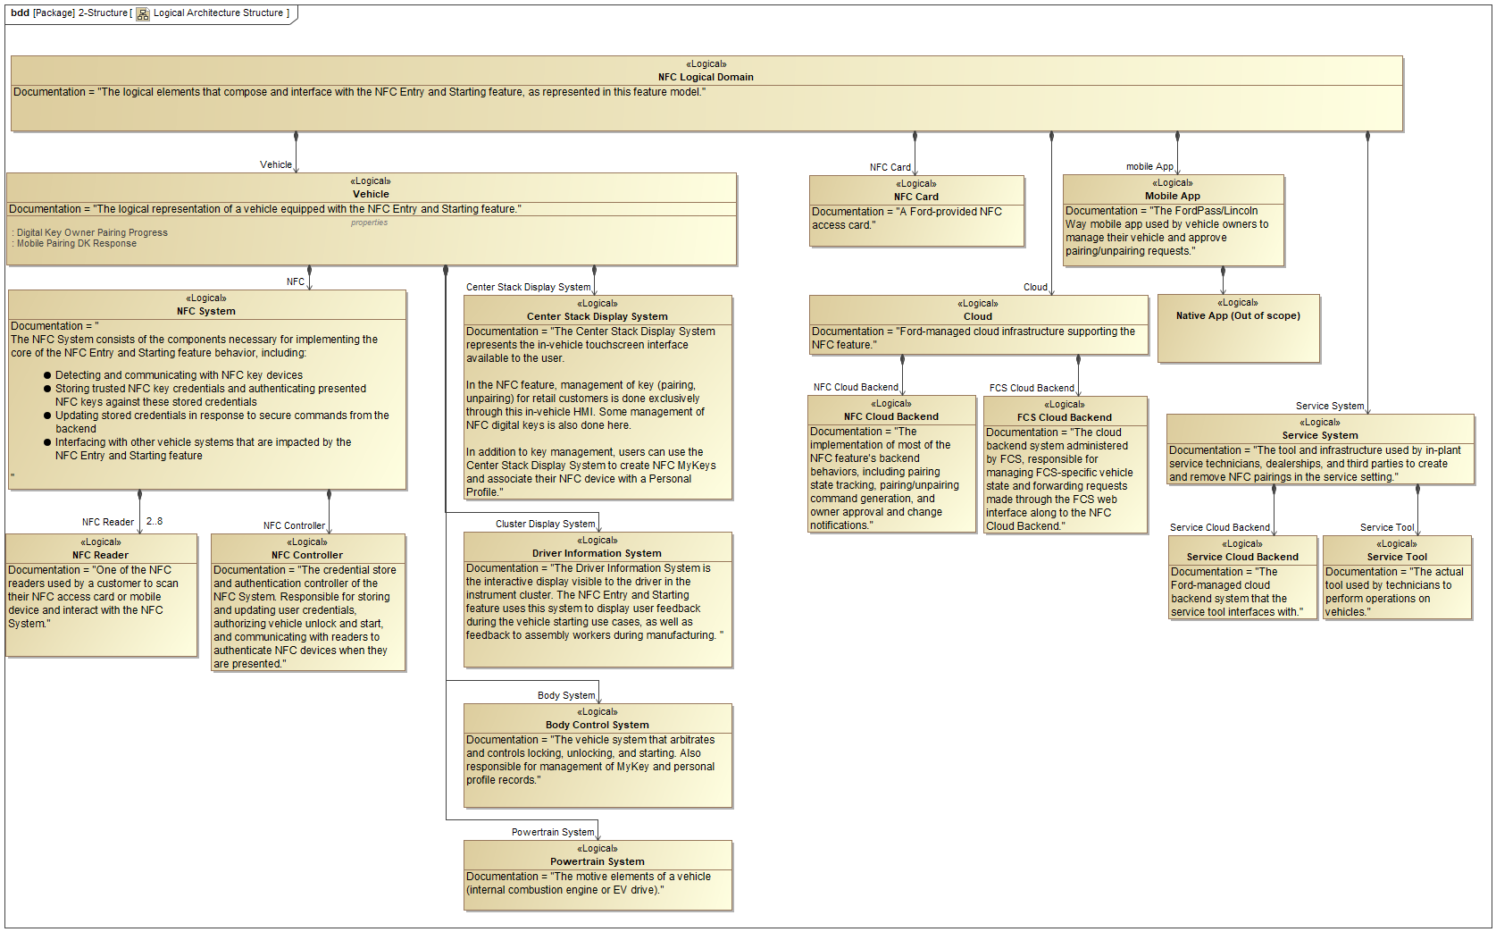

Figure 1: NFC Logical Domain Structure

## Logical Architecture

The Logical Architecture diagram shows the messages that flow between different elements of the NFC Logical Domain. Details on the contents of the messages shown here can be found in the Data Dictionary provided as an appendix.

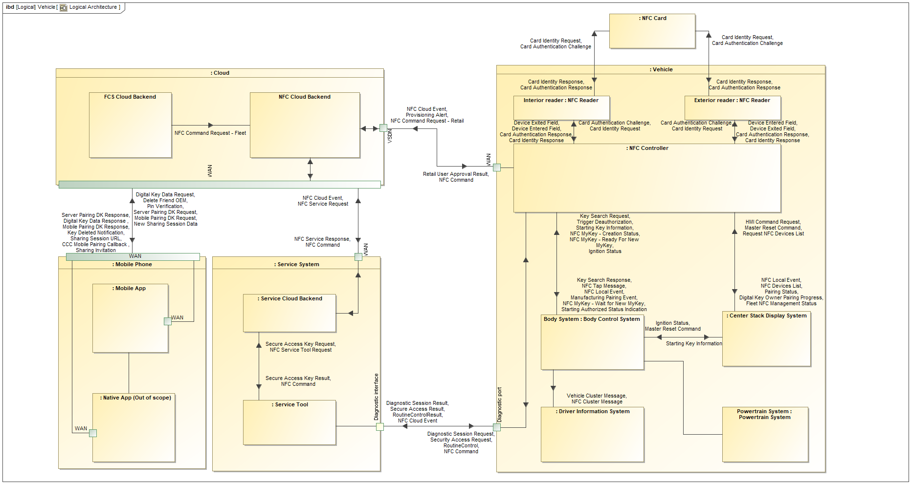

Figure 2: NFC Logical Architecture

# Function Group Description

This specification consists of documentation about the logical system component 870598806.png **Driver Information System**.

The Driver Information System is the interactive display visible to the driver in the instrument cluster. The NFC Entry and Starting feature uses this system to display user feedback during the vehicle starting use cases, as well as feedback to assembly workers during manufacturing.

## Logical System Behavior

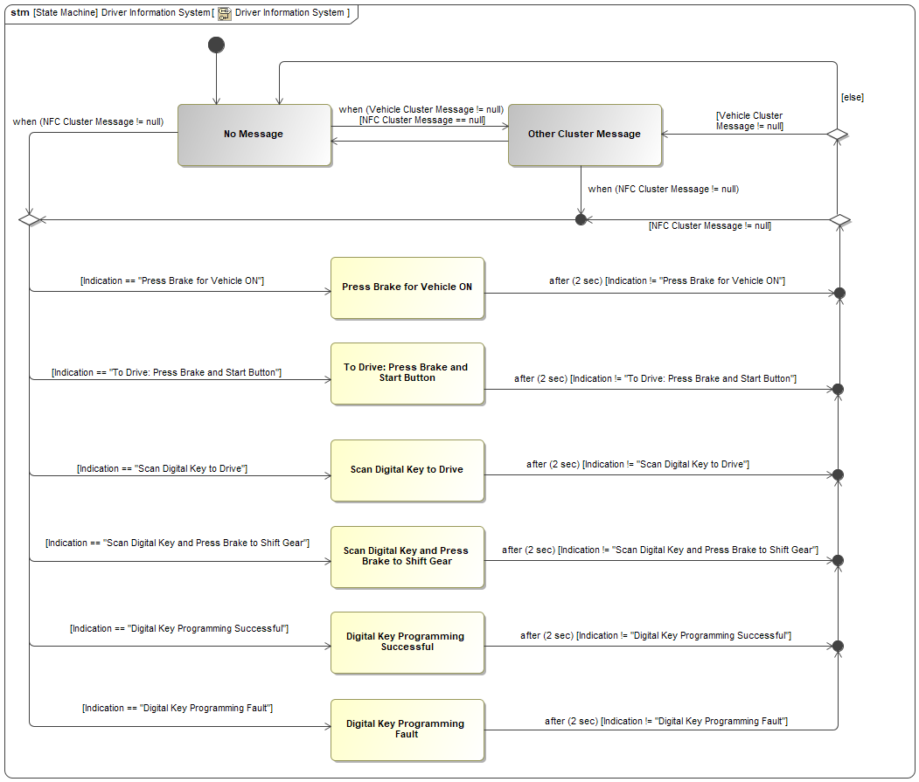

Figure 3: Driver Information System

## Logical System Requirements

REQ-NFC-ES-307 Locking and starting function even without display system

The NFC system shall fulfill the unlocking, locking, and vehicle starting functions without depending on communications with, or the operation of, the in-vehicle display system.

**Acceptance Criteria:** Enter and Start the vehicle with missing or disconnected Sync module

REQ-NFC-ES-311 Driver Information System: message display logic

The Driver Information System shall display warnings based on the "Indication" signal of the "NFC Cluster Message" and "Vehicle Cluster Message" as follows:

|  |  |  |
| --- | --- | --- |
| **NFC Cluster Message** | **Vehicle Cluster Message** | **Display** |
| To Drive Press Brake And Start Button | X (don't care) | To Drive: Press Brake And Start Button |
| Press Brake for Vehicle ON | X (don't care) | Press Brake for Vehicle ON |
| Scan Digital Key To Drive | X (don't care) | Scan Digital Key To Drive |
| Scan Digital Key And Press Brake To Shift Gear | X (don't care) | Scan Digital Key And Press Brake To Shift Gear |
| Digital Key Programming Successful | X (don't care) | Digital Key Programming Successful |
| Digital Key Programming Fault | X (don't care) | Digital Key Programming Fault |
| Null | *Any value* | Message specified in "Vehicle Cluster Message" signal |

REQ-NFC-ES-312 Driver Information System: "Scan Digital Key And Press Brake To Shift Gear" message details

When the Driver Information System displays the message "Scan Digital Key And Press Brake To Shift Gear", it shall have the following characteristics:

|  |  |
| --- | --- |
| **Message color** | Amber |
| **Play chime when message displayed** | No |
| **Show icon with message** | Yes |

REQ-NFC-ES-313 Driver Information System: "Scan Digital Key To Drive" message details

When the Driver Information System displays the message "Scan Digital Key To Drive", it shall have the following characteristics:

|  |  |
| --- | --- |
| **Message color** | Amber |
| **Play chime when message displayed** | No |
| **Show icon with message** | Yes |

REQ-NFC-ES-314 Driver Information System: "To Drive: Press Brake And Start" message details

When the Driver Information System displays the message "To Drive: Press Brake And Start Button" message, it shall have the following characteristics:

|  |  |
| --- | --- |
| **Message color** | Amber |
| **Play chime when message displayed** | No |
| **Show icon with message** | No |

REQ-NFC-ES-315 Driver Information System: "Digital Key Programming Successful" message details

When the Driver Information System displays the message "Digital Key Programming Successful", it shall have the following characteristics:

|  |  |
| --- | --- |
| **Message color** | Amber |
| **Play chime when message displayed** | No |
| **Show icon with message** | No |

REQ-NFC-ES-316 Driver Information System: "Digital Key Programming Fault" message details

When the Driver Information System displays the message "Digital Key Programming Fault", it shall have the following characteristics:

|  |  |
| --- | --- |
| **Message color** | Amber |
| **Play chime when message displayed** | No |
| **Show icon with message** | No |

REQ-NFC-ES-317 Driver Information System: display time for "To Drive: Press Brake and Start Button", "To Drive: Press Brake and Select D/R Gear", and "Scan Digital Key To Drive"

When any of the following messages are triggered on the Driver Information System:

* "To Drive: Press Brake And Start Button"
* "Press Brake for Vehicle ON"
* "Scan Digital Key To Drive"

that message shall continue to be displayed until the input signals that caused it to be displayed are changed. After the input signals change, the Driver Information System shall no longer display the message.

REQ-NFC-ES-318 Driver Information System: display time for "Scan Digital Key And Press Brake to Shift Gear" message

After the "Scan Digital Key And Press Brake to Shift Gear" message is triggered, it shall continue to be displayed on the Driver Information System until one of the following occurs:

* The "OK" button is pressed
* The input signals that caused the message to be displayed change their value

When any of the conditions listed above occurs, the Driver Information System shall stop displaying the message immediately.

REQ-NFC-ES-319 Driver Information System: display time for NFC key programming messages

When any of the following messages are triggered on the Driver Information System:

* "Digital Key Programming Successful"
* "Digital Key Programming Fault"

that message shall continue to be displayed until any of the following occurs:

* + Four seconds elapse from the time the message was triggered
  + The "OK" button is pressed
* When any of the conditions above occur, the Driver Information System shall stop displaying the message.

REQ-NFC-ES-320 Driver Information System: message availability in Limited mode

When the vehicle is in Limited mode (ignition state is not RUN), the following messages shall be displayed if their trigger occurs:

* "To Drive: Press Brake And Start Button"
* "Press Brake for Vehicle ON"
* "Scan Digital Key To Drive"
* "Digital Key Programming Successful"
* "Digital Key Programming Fault"

REQ-NFC-GE2-1 Driver Information System: To Drive: Press Brake And Select D/R Gear message details

When the Driver Information System displays the message "To Drive: Press Brake And Select D/R Gear" message, it shall have the following characteristics:

|  |  |
| --- | --- |
| **Message color** | Amber |
| **Play chime when message displayed** | No |
| **Show icon with message** | No |

# Revision History

|  |  |  |  |
| --- | --- | --- | --- |
| Revision | Date | Description | Responsible |
| 2020-08-24 | 8/24/2020 | Initial Functional Specification release for UPV1 | abonnel1, fehsan2,  ekarpins |
| 2020-11-09 | 11/9/2020 | Update all functional requirements to reflect latest design. Update behavior diagram for Driver Information System. Add “Vehicle Cluster Message”. Rename “Driver information indication” to “NFC Cluster Message”. Update “NFC Cluster Message” encoding type with new warnings. Remove Nisha Patel from stakeholders list. | abonnel1, fehsan2, ekarpins |
| 2020-11-10 | 11/9/2020 | Modified REQ-NFC-ES-319 and REQ-NFC-ES-320 text based on STSS author feedback to align with HMI Global Message List | abonnel1, fehsan2, ekarpins |
| 2021-06-08 | 6/8/21 | Update data dictionary.  Add logical architecture information.  Updated Figure 3  Added Requirements:   * REQ-NFC-ES-312 * REQ-NFC-ES-313 * REQ-NFC-GE2-1   Updated Requirements:   * REQ-NFC-ES-311 * REQ-NFC-ES-317 | abonnel1, adelong2, fehsan2,  ekarpins, jwolf53, rsepulv6 |

# Appendix

## Data Dictionary

### Logical Messages

NFC Cluster Message

|  |  |
| --- | --- |
| **Name** | **NFC Cluster Message** |
| **Description** | Message sent from the Body Control System to the Driver Information System that indicates which NFC-specific driver warning message should be displayed. |
| **Realized by** |  |

**Parameters/Owned Signals**

|  |  |  |  |
| --- | --- | --- | --- |
| **Name** | **Type** | **Description** | **Realized By** |
| 963127440.png Indication | -1102010346.png NFC Cluster Message | Which message should be displayed on the cluster. |  |

Vehicle Cluster Message

|  |  |
| --- | --- |
| **Name** | **Vehicle Cluster Message** |
| **Description** | Existing message sent from the Body Control System to the Driver Information System that causes specific warning messages to be displayed on the cluster. |
| **Realized by** |  |

**Parameters/Owned Signals**

|  |  |  |  |
| --- | --- | --- | --- |
| **Name** | **Type** | **Description** | **Realized By** |
| 963127440.png Indication |  | Which message should be displayed on the cluster. |  |

### Logical Data Types (encodings)

-1102010346.png NFC Cluster Message

The NFC feature-related messages that can be displayed in the vehicle's cluster.

**Encoding** **values**

|  |  |  |
| --- | --- | --- |
| **Enumeration Value** | **Enumeration Value Description** | |
| Scan Digital Key To Drive | Cluster message prompting the user to scan an authorized NFC device in order to start or drive the vehicle |
| To Drive Press Brake And Start Button | Cluster message prompting the user to start the vehicle after they have scanned their NFC device |
| Null | No NFC feature-related indication requested. |
| Scan Digital Key And Press Brake To Shift Gear | Cluster message prompting the user to scan an NFC device in order to exit Secure Idle or Remote Start |
| Digital Key Programming Successful | Cluster message indicating that an attempt to pair an NFC device while in Factory Pairing Mode was successful |
| Digital Key Programming Fault | Cluster message indicating that an attempt to pair an NFC device while in Factory Pairing Mode has failed |

### Technical Signals

#### GSDB Signals

ImmoMsgTxt_D_Rq

|  |  |
| --- | --- |
| **Signal Name** | **ImmoMsgTxt_D_Rq** |
| **Description** | Provides a trigger indication to IPC after BCM system performs key search |
| **Encoding** | 230697813.png immoMsgTxt_D_Rq_ET |
| **Transmitter** | -2042894189.png BCM |
| **Receiver** | -2042894189.png IPC |
| **Logical Signal** | 662243001.png Key Search Request  1569026423.png Vehicle Cluster Message  963127440.png Indication |

NfcDevc_D_Dsply

|  |  |
| --- | --- |
| **Signal Name** | **NfcDevc_D_Dsply** |
| **Description** | This signal is transmitted by Body Control Module (BCM) as a result of key search to trigger Near Field Communication (NFC) related warnings in cluster. |
| **Encoding** | 230697813.png NfcDevcDsply_D_Rq_ET |
| **Transmitter** | -2042894189.png BCM |
| **Receiver** | -2042894189.png IPC |
| **Logical Signal** | 1569026423.png NFC Cluster Message  963127440.png Indication |

Document ends here.